EXPERIMENT NO : 3

Path Loss, Received Power
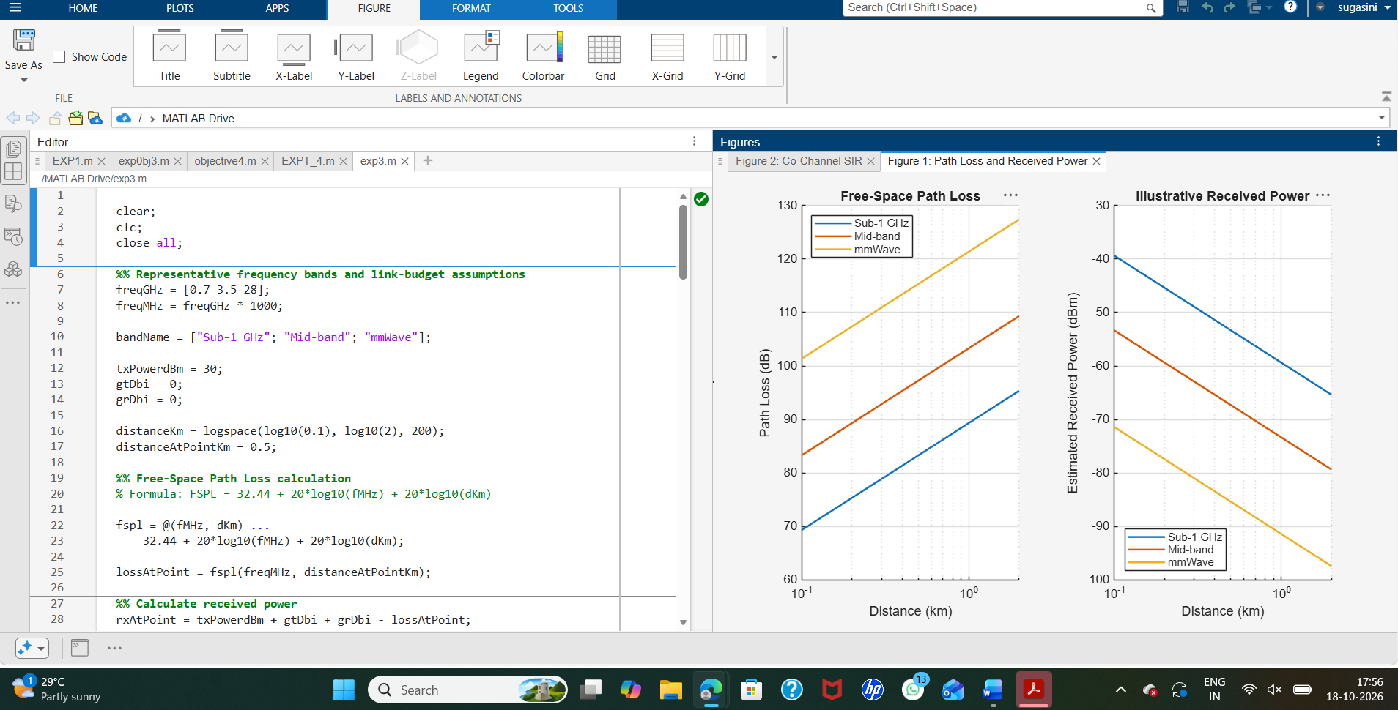

Reuse Interference
